One-page design document

Game Identity / Mantra
Quick-time minecart game avoiding obstacles and setting time records.

Design Pillars
Fast: The player’s goal is to clear tracks in the fastest way possible.
Action: The player has to make time based decisions and react quickly to avoid obstacles and slowing down.
Competition: The player’s times will be shown in a scoreboard, which they can compare to other players.

Genre/Story/Mechanics Summary
The player is riding a minecart and has to lean to the sides, front, and back to gain or reduce their speed. Due to the competitive side, the game is classified as a racing game.

Features
Motion input, to be replaced with kinesis.
Allows for competitive gaming.

Interface
The player uses the Crown’s accelerometer as input in the first prototype.
In the future, this will be replaced by kinesis, imagining leaning left and right.

Art Style

Reference image minecart.

Reference image tracks.
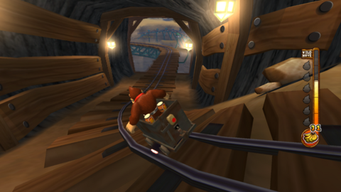
Reference image environment.
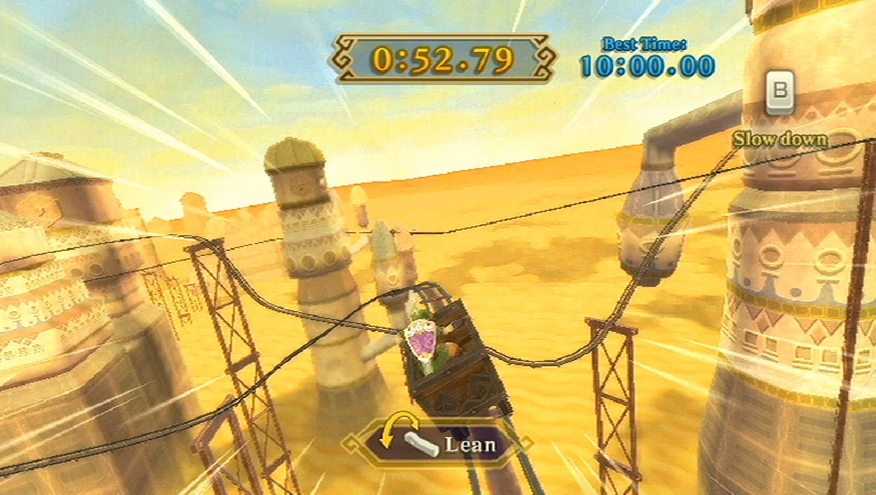
Reference image track design.
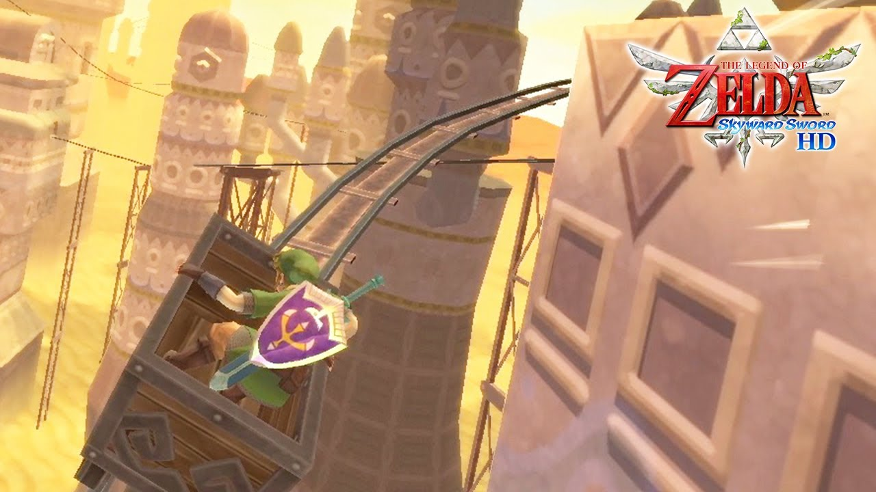Reference image leaning mechanic.

Music / Sound
As the prototype is aimed to demonstrate the functionality of the Crown, the game does not have music or sound, as it is not crucial for the end product.

Development Roadmap / Launch Criteria
Platform: Windows.
Audience: All ages and genders, interested in racing / quick time events.

Milestone 1: Models complete - 12/01/2024
Milestone 2: Mechanics complete - 17/01/2024
Milestone 3: Levels complete - 19/01/2024
Launch Day: 19-01-2024

